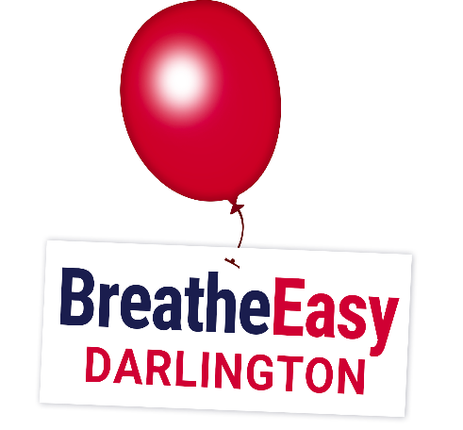
Darlington Group

Welcome to Breathe Easy Darlington.
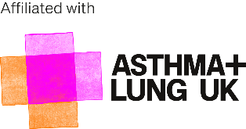
The volunteers who run the group, which is affiliated to Asthma and Lung UK, would be very grateful if you would complete the following details.
The reason that we ask for them is simply so that we can keep in touch with you, for example, to let you know about forthcoming meetings, events and activities (or of their cancellation), to send our newsletter, arrange speakers who may be of interest to the group, forward you information from other groups, to help
Breathe Easy Darlington to publicise its existence and to campaign for health care improvements, especially those which involve respiratory diseases. We promise -

- We will always store your personal data securely and only for as long as necessary. We will not share it without your permission. We would never pass it on to a third party. Only those directly involved with running the group will have access to your details.
- We will never exchange or sell your information to another organisation.
- We will always give you control of how we use your information. You will always have the right to ask us to stop using it (see foot)
- We will only contact you in the ways that you wish. The information you give us, or give publicly, will allow us to make sure our communications to you are relevant.

Please fully complete and sign this form and return it to the address at the foot of this form.
Choosing not to answer/accept any of these points in no way affects your membership, subject to Group Rules (below).
Title First Name Surname

Address

Postcode

Email Address Telephone Number

Mobile Number What is your Lung Condition?

May we use any photographs you appear in for local publicity, on our Facebook page and other social media resources including the Breathe Easy Darlington website?

May we store information of your illness suffered?
Yes No

Yes No

May we use your name against photographs or in press articles (something we do not need to do very often)
Yes No

Where did you hear about this group? Emergency Contact Number

I promise to abide by the Group Rules as follows - 1) - Be Kind and Courteous so as to create a welcoming environment. Treat everyone with respect. Healthy debates are natural, but kindness is required. 2) No Hate Speech or Bullying, make sure everyone feels safe. Bullying of any kind isn't allowed, and degrading comments about things like race, religion, culture, sexual orientation, gender or identity will not be tolerated. 3) All COVID denial or anti-vaccine posts will not be passed to the page by Admins 4) - No advertising will be passed to the page by Admins. unless they are from affiliated groups or suppliers
To be considered for the Membership - complete this Application Form in full, have a diagnosed lung disease or be a Carer,
a family member or a friend of a current member resident in Co.Durham, Teesside or N.Yorks.)

Signature Date

If you no longer wish to receive Breathe Easy Darlington emails, or wish to make any other alteration, please inform us by post to
:- Mr M Dunstone, 59 Victoria Embankment,
Darlington DL1 5JS, email malcolmdunstone17@gmail.com

For further information please contact us on email at breatheeasydarlington@hotmail.com
or Louise - 07552 684500 or Gill – 07734993188

